MODULE 4
In this Module, we have learnt about how Future Scope, Cancellation Rate on the basis of Year and Month, Lead Time Distribution by the BookingID, and Refund and No Show count.
Formulas used are-:
NoShowCount =
CALCULATE(
COUNTROWS(Bookings),
Bookings[BookingStatus] = "No-Show"
)

RefundCount =
CALCULATE(
COUNTROWS(Bookings),
Bookings[RefundAmount] > 0
)

CancellationRate =
DIVIDE(
COUNTROWS(FILTER(Bookings, Bookings[CancellationFlag] = "Yes")),
COUNTROWS(Bookings)
)

VISUALISATION-:
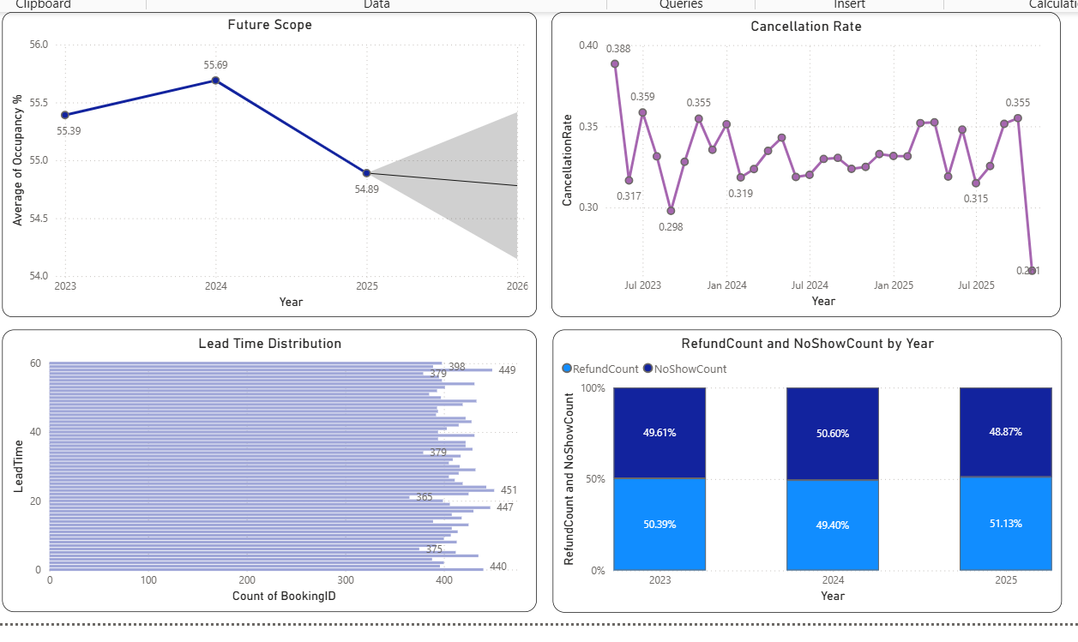
Next we have created the Ancillary Transactions table with the following formula.
let
Source = Bookings,
ValidBookings = Table.SelectRows(Source, each [CheckInDate] <> null and [CheckOutDate] <> null),

// Add Index column for cycling
WithIndex = Table.AddIndexColumn(ValidBookings, "Index", 0, 1, Int64.Type),

// Assign ServiceType based on Index modulo 4
WithServiceType = Table.AddColumn(WithIndex, "ServiceType", each
let r = Number.Mod([Index], 4)
in
if r = 0 then "Spa"
else if r = 1 then "Dining"
else if r = 2 then "Gym"
else "Laundry"
),

// Add Item based on ServiceType
WithItem = Table.AddColumn(WithServiceType, "Item", each
if [ServiceType] = "Spa" then "Swedish Massage"
else if [ServiceType] = "Dining" then "Buffet Dinner"
else if [ServiceType] = "Gym" then "Personal Training"
else "Laundry Service"
),

// Quantity 1 to 4 based on Index
WithQuantity = Table.AddColumn(WithItem, "Quantity", each 1 + Number.Mod([Index], 4)),

// Amount based on ServiceType
WithAmount = Table.AddColumn(WithQuantity, "Amount", each
let base =
if [ServiceType] = "Spa" then 2000
else if [ServiceType] = "Dining" then 1800
else if [ServiceType] = "Gym" then 1600
else 1200
in base * [Quantity]
),

// Transaction Date within stay period
WithDate = Table.AddColumn(WithAmount, "Date", each
let los = Duration.Days([CheckOutDate] - [CheckInDate]),
offset = Number.Mod([Index], los + 1)
in Date.AddDays([CheckInDate], offset)
),

// TransID
Final = Table.TransformColumns(WithDate, {
{"Index", each "ANC" & Text.PadStart(Text.From(_ + 1), 5, "0"), type text}
}),

AncillaryTable = Table.SelectColumns(Final, {"Index", "BookingID", "CustomerID", "Date", "ServiceType", "Item", "Quantity", "Amount"})
in
AncillaryTable
The following measures were also added.
Upsell Conversion % = DISTINCTCOUNT('Ancillary Transactions'[BookingID]) / DISTINCTCOUNT(Bookings[BookingID])
Ancillary Rev / Booking = DIVIDE(SUM('Ancillary Transactions'[Amount]), COUNT(Bookings[BookingID]))

Ancillary Revenue = SUM('Ancillary Transactions'[Amount])

On what is the Service Type, we have created the visuals.

VISUALISATION:
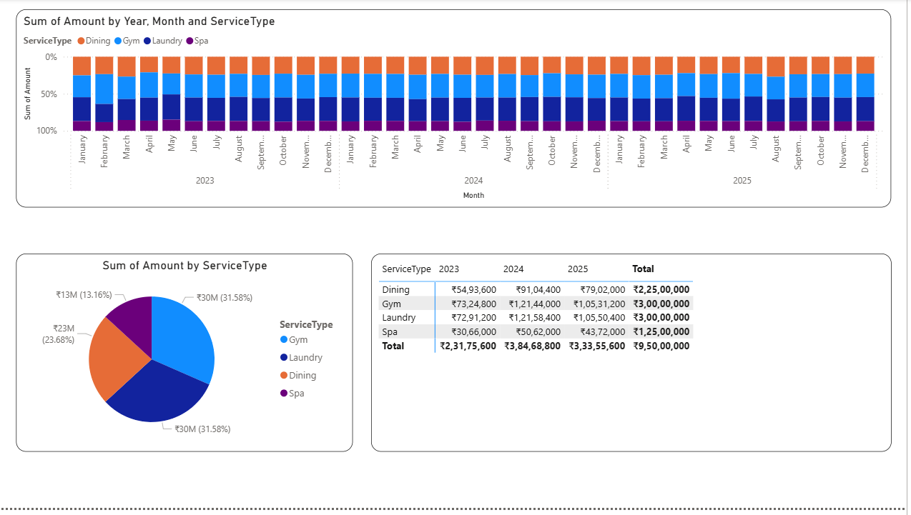

MODULE 5
In this module, we have created recommended price measure along with seasons table and 2 parameters namely, Occupancy Sensitivity and Price Uplift %
For occupancy sensitivity:
Minimum 0.8
Maximum 1.2
Increment 0.05
Default 1

For price uplift %:
Minimum -0.1
Maximum 0.2
Increment 0.01
Default 0

Recommended Price =
VAR BaseADR = [DADR] -- Use your valid ADR measure
VAR SeasonAdj =
SWITCH(SELECTEDVALUE('Date'[Season]),
"High", 0.15,
"Shoulder", 0.05,
"Low", -0.10,
0
)
VAR Uplift = [Price Uplift % Value]
VAR Elasticity = [Occupancy Sensitivity Value]
RETURN
BaseADR * (1 + SeasonAdj + Uplift) * Elasticity

Season =
DATATABLE(
"MonthNumber", INTEGER,
"MonthName", STRING,
"Season", STRING,
{
{1, "January", "High"},
{2, "February", "Shoulder"},
{3, "March", "Shoulder"},
{4, "April", "Low"},
{5, "May", "High"},
{6, "June", "Low"},
{7, "July", "High"},
{8, "August", "Shoulder"},
{9, "September", "Low"},
{10, "October", "Shoulder"},
{11, "November", "Low"},
{12, "December", "High"}
}
)

VISUALIZATION:
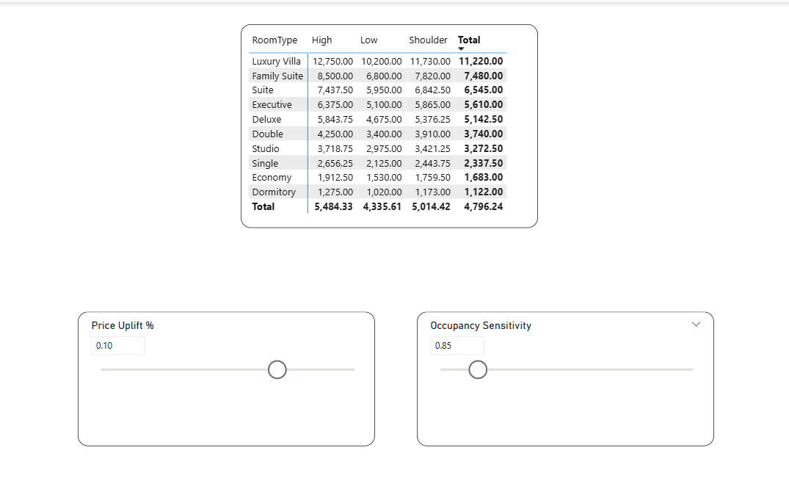

Now on the basis of all the 5 modules, General Manager Dashboard and Revenue manager Dashboard was created.
GENERAL MANAGER DASHBOARD:
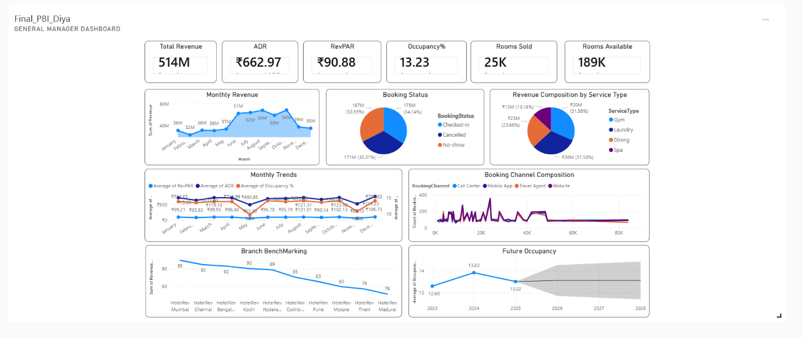

REVENUE MANAGER DASHBOARD:
